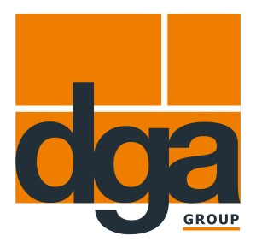

Press Release 18.12.2017
A strong bond with BIGUMA®- Connect
Dortmunder Gußasphalt presents a new joint sealant at InfraTech in Essen

With the launch of BIGUMA®- Connect, Dortmunder Gußasphalt GmbH & Co. KG, a leading manufacturer of bituminous road and building construction products, is expanding its product portfolio in the joint sealant segment.
This allows the company to offer its customers a number of benefits. While conventional joint sealants inevitably require a primer, BIGUMA®- Connect can be filled entirely without the need for a primer. The innovative polymer composition of this joint sealant ensures excellent adhesion, particularly on mineral substrates. This renders the use of a primer superfluous and eliminates the time-consuming processes of primer application and drying times.
“Building contractors work under considerable time pressure at the construction site – after all, the road has to be passable again very quickly. By using BIGUMA®- Connect, they eliminate an entire work step, and consequently, save time and money”, explains Sales Manager Stefaan Haerinck.

Roads are also suffering from climate change
Climate change is creating progressively extreme weather conditions that do not stop at the European borders, leaving their mark on roads and imposing high demands on road construction products. Dortmunder Gußasphalt has developed BIGUMA®- Connect as a clear response to the increasingly extreme weather conditions, since this joint sealant provides excellent thermal stability at high temperatures and exceptional flexibility at low temperatures. In addition, this innovative product features optimised flow behaviour even at lower processing temperatures starting at 160°C.At InfraTech, the trade fair for road construction and civil engineering, Dortmunder Gußasphalt GmbH & Co. KG will present the new BIGUMA®- Connect joint sealant to a wide professional audience for the first time. Interested visitors can find comprehensive information about the new product at booth 3B29.

Text information
Length: 1.997 characters including spaces
Status: 18 December 2017
Image 1: BIGUMA®- Connect is filled entirely without the use of primer
Image 2: With BIGUMA®- Connect, filling is fast and cost-efficient

Press contact
Katharina Skubisz
Dortmunder Gußasphalt GmbH & Co. KG
Phone: 0231/395797 - 88
E-mail: katharina.skubisz@dga.de

