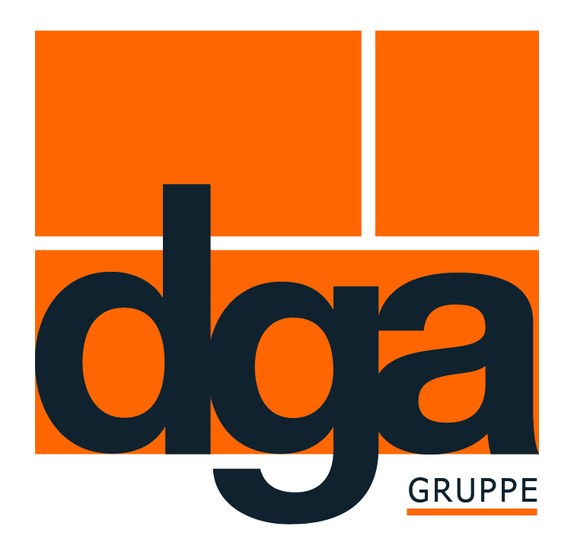

Press Release 20.11.2019
Effective road solutions from a single source with the BIGUMAtor®- processing machines
dga-Group has been developing the BIGUMAtor®- MB for simple joint tape processing

With the BIGUMAtor®- MB, Dortmunder Gußasphalt GmbH & Co. KG, a leading manufacturer of road construction materials, is pleased to introduce an appropriate processing machine for its newly developed machine joint tape – allowing it to offer its customers an effective road construction solution from a single source. This makes connections in asphalt road construction easy and reliable to seal.

“Problems during processing on the construction site can only be avoided if the product and processing machine are optimally coordinated. The demand from our customers for such solutions has risen dramatically in the past few years”, declares Stefaan Haerinck, Sales Manager at Dortmunder Gußasphalt. Because any delay on the construction site costs time and money.
Stefaan Haerinck: “We aim to continue developing suitable processing machines for our products in the next few years. The BIGUMAtor®- MB is the second machine from this series after the BIGUMAtor®- MT Sealer.”

Bespoke joint tape processing thanks to individual setting options
The hand-guided BIGUMAtor®- MB enables the BIGUMA®- M Band to be laid exactly, the latter’s unique composition making it ideally suitable for machining by extrusion. No matter whether milled edges, cut edges or rolled flanks – BIGUMA®- M Band allows joints between mounting sheets of different mix properties, fittings and concrete to be sealed.
Here the BIGUMAtor®- MB, which is fitted with the tape and brought to operating temperature after a short time, is placed on the joint flank to be processed, after which the connections are aligned and the tape formed by the machine is installed with total precision. The result is impressive: Large sections of joint tape can be laid quickly and economically within a short time.

The individual setting options of the extruder enable different tape dimensions to be processed. The travel speed can also be set individually. BIGUMAtor®- MB is CE certified.

Text informationen
Scope: 2,173 characters including spaces
Version: 20 November 2019
Picture 1: The BIGUMAtor®- MB excels with its easy handling and individual setting options

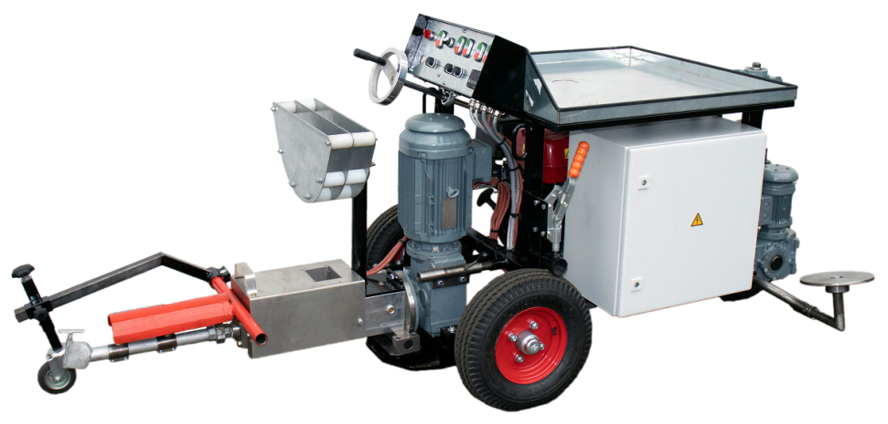

Presse contact
Katharina Skubisz
Dortmunder Gußasphalt GmbH & Co. KG
Phone: 0231/395797 - 88
E-mail: katharina.skubisz@dga.de

